SHROVE TUESDAY 2021

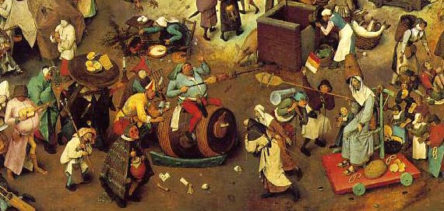

This is the day on which we can celebrate and enjoy the last day before the fasting (literal or metaphorical!) for the 40 days of Lent. Traditionally we observe doing without something we enjoy, but we can also choose to work on a habit, an attitude, a hardness of heart, that needs breaking, or at least our attention devoted to changing it, so we are better, more self-giving as Christians. One year I established that habit of driving slower, more considerately, and blessing those on the roads where rage and frustration was at its peak: my prayerful intentions worked and I did change, by the grace of God! Anglo Saxons went to confession and were ‘shriven’ or absolved of their sins. We can do this right now – and enjoy a pancake along the way! Whatever we have in our cupboards that is delicious and a treat should be eaten so we are not tempted!
We might not be able to have a village bash and banquet like the one we see in the picture, or we might choose to have a simple inner awareness of what lies ahead in our personal journey, but we step into the merriment, and, enjoy a pancake!
Here is the pancake recipe I remember from childhood:
4 Tablespoons of flour. 2 Tablespoons of sugar. Half a teaspoon of baking powder. I egg, a pinch of salt, and milk to get the pouring consistency. Ladle it into a hot frying pan. When the mix bubbles, turn it over, or toss it in the air! Or, whilst flipping it, run across your lawn or down your street in true tradition! Serve hot with whatever filling your pantry provides, or cinnamon, sugar (already mixed is best), and a squeeze of lemon juice.
Of course, if you prefer to imagine all this, enjoy doing it that way!
Reflect on what THIS Lent will mean for you. Pray for your family, living and departed; your friends, those in need. Our community and indeed, the world.
Remember, you are not alone. We will be getting a booklet to you for your daily readings, and I will be emailing you similar letters.
Do join us on Tuesday or Wednesday evenings on Zoom, at 7 and 8 respectively, for our weekly meditations on the themes

