SEVEN WORDS FROM THE CROSS
FOR GOOD FRIDAY

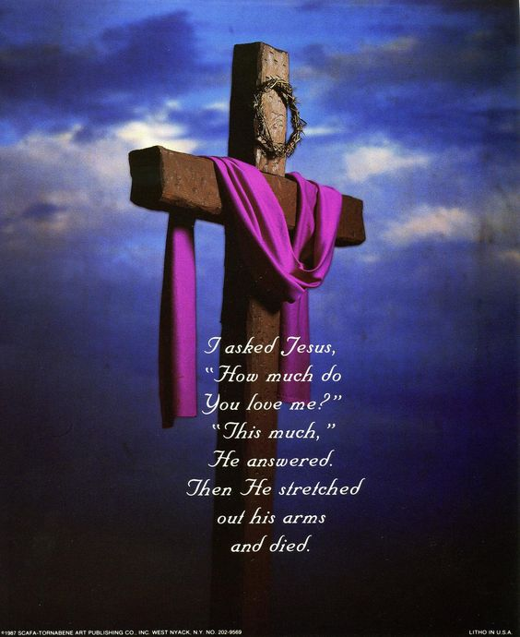

This service starts at 12 noon, the time Jesus died. We reflect on the last words uttered.
Each reflection will be preceded by music for prayer. Words in bold are said together.
- Father, forgive them, for they no not what they are doing
Meditation and music
Before you die, Jesus Christ,
And the world goes into deep darkness,
Take our lives, from our souls,
From our consciences
All that has offended you,
All that has hurt others.
And the obstinacy
Which has made us numb
To the plight of those whom we could help or heal.

Lamb if God, you take away the sin of the world
Have mercy upon us
Lamb of God, you take away the sin of the world
Have mercy on us.
Lamb of God, you take away the sin of the world
Grant us your peace
On this day, at this time,
Irrespective of our faith or lack of it,
We accept deeply in our hearts
The only words that can set us free;
Your sins are forgiven,
Your sins are forgiven. Amen
Music and reflection……………………………..

- Today you will be with me in paradise
Lord Jesus, remember us
When you come into your kingdom
Remember us, not for our impressive CV.
Nor the things we hope will appear in our obituaries
Remember us
Not for the virtues we occasionally display
Or for any credit
We think we have in our oral account.
Remember us,
As one of the criminal community
Who hung at your side,
And if life will not let us be in paradise
With you today,
Keep a place for us.
Amen

Music and reflection……………………………….

- Mother, there is your son……………
For our families, where they are open, loving, supportive,
That their joy might be kept safe, Lord hear us,
Lord graciously hear us

For our families,
Where they are tense, troubled, fragmented,
That they may find a way through the pain,
Not a path away from it,
Lord hear us.
Lord, graciously hear us

For our churches,
Where they have become introverted
Suspicious of the stranger
Obsessed with dead rather than living stones
Suffocated by correctness and tradition
That they might be redeemed
From the pawnshop of past glory
And renewed by the power of the Holy Spirit
Lord, hear us.
Lord, graciously hear us

For ourselves, in this place of worship
Surrounded by people
Whose journey we have not travelled,
Whose depth of faith we do not know,
Whose potentials we cannot imagine,
That we might somehow know we belong to each other
Lord, graciously hear us

And before you leave the cross
And we vacate this building,
If there is one of our family
For whom we should care more fondly,
Direct our gaze to them,
As you turned Mary towards John.
Amen
Silence and meditation………………

- My God, my God, why have you forsaken me?
Lord Jesus
By your cry of desperate honesty,
Rid us of superficial faith
Which is afraid of the dark.

Not so that we might be justified pessimists,
But so that we might discover profound joy.
Give us, when we need it,
The courage to doubt, to rage, to question,
To rail against heaven until we know that we are heard.

We do not ask for easy answers to hard times;
There are many who can offer these.

We ask for a sense of your solidarity,
That will be enough
To let us know
That we do not walk or cry alone;
That will enable us to go through the dark
And find light again in the morning
Amen
Silence and meditation………………
Amen
- I am thirsty
You have made us for yourself.
We know it, even if we cannot name it.
We have had these bodies and these minds
Long enough to learn to live with our limitations
Yet, despite this, something hankers, yearns, thirsts
For something better, which we know is there.

Beautiful music ends
And we wish it could continue.
We embrace,
Then refrain from embracing
And wish that we could be held forever’
We think deeply, or feel deeply
And wish that this sense of being caught up in living
Would not be interrupted by the mundane things of life.

We sense the disappointment
In dashed hopes that deserve to be fulfilled.
In missed opportunities
Which should have led to joy not frustration.
In people whose potential has been buried
or denied and deserves to flourish.

So much of life demands a resolution.
So thank you for this incompleteness,
Thank you for this yearning,
Thank you for this thirst.
Thank you for giving us enough of you to want more,
And to sense the fullness of eternity
With the limits of time.

- It is finished
Now Lord Jesus,
You can let go of us.

You have convinced us of our sin
And you have forgiven it.
You have convinced us of your way
And have engaged us on it.
You have shown us a foretaste of heaven
And have made us a part of it.
You can let go of us now.

Having overcome the sin of the world,
Death will be a small obstacle
Just as you foretold
That you would be handed over to be crucified
And this has come true; also you foretold
That on the third day You will rise again
And we will be your witnesses.
Amen
Silence and meditation………………

- Father, into your hands I commit my Spirit

God, who before your birth, called you into being,
Now calls you back, his accent still the same.

Lord Jesus, we will let you go.
You cannot cling to life forever,
Nor can we cling to a dying frame, nor do we grudge you
That peace which passes all understanding
Which you have promised to us.

Go to heaven, where you will welcome those
Who die in your faith
Whose death, with your death, we remember
Tell them that we love them. That we miss them.
Even if we need to forgive them,
That they are not forgotten.

And cheered by the prospect of a day
When there will be no more death or parting.
And all shall be weak, and all shall be one,
May they who have died before us
Be among the first to welcome us to heaven
Where, with you enthroned in glory,
And in the company of the Blessed Virgin Mary,
And all the saints, Keep us in faith, fill us with hope,
Deepen us through love,
To the glory of your holy name
Amen
Silence and meditation………………

Please leave the church in silence.
You are welcome to stay as long as you like.
Seven words from the Cross’ copyright 1998 Iona Community Glasgow G51 3UU

