AREA COUNCIL ST ANDREWS EAST

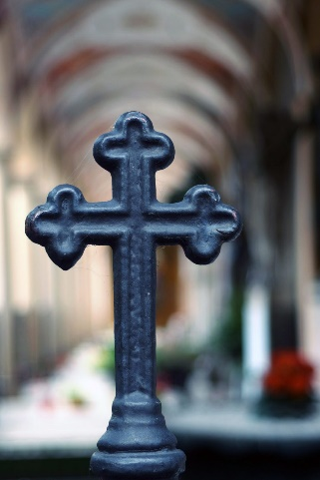

Our first Area Council will meet on Thursday evening 20 May under the leadership of Rev Roy Annetts and Margaret Gray. At the moment we are still in the process of organising a varied programme of events.
Our first meeting will be a zoom event which hopefully, as many as possible of your church congregation, will be able to attend. The subject is Climate Change which is an extremely topical emotive suject within our diocesis. Our speaker will be Professor Alan Werrity from the University of Dundee who is going to give a power point presentation.
We are still waiting for further details but it might be useful if you could give us a list of people and email addresses attending so that we organise the disrbution of zoom invitations.
We look forward to seeing you all
Best wishes
Rev Roy Annetts
Margaret Gray

