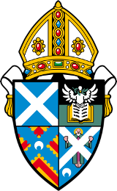 Diocese of St Andrews, Dunkeld and Dunblane

St Mary’s Newport on Tay and St Margaret’s Tayport

We are looking to appoint a part time Priest in Charge to minister to the two congregations in the linked charge, situated along the south side of the River Tay, between Dundee and St Andrews. Both have small, faithful and enthusiastic membership.

We offer accommodation in a three-bedroom house in Newport on Tay, and 25% standard stipend. The post is for Sundays plus the equivalent of 2 days per week
Further information can be obtained from info@stmaryschurchnewportontay.org.

We seek someone with energy and vision, who could lead us in spiritual growth and membership, who has pastoral skills, and who is willing to maintain wider community and ecumenical links.

Closing date for applications 31st May 2019

Date of interview 27th June 2019

Appointment subject to a satisfactory enhanced Disclosure Scotland check.

SC003380 and SC008963

